**Marketing Campaign for Decreal Gear**

**Section 1**

**Rationale**

**Aims and Objectives**

* Main Aim: Aim to increase sales by 10% over a 1 and a half year period.

Ways I can do this is by using certain promotional methods such as coupons and coupons is a good method as it incises people to use them as they may provide certain

**Research**

* Primary Research
* Secondary Research

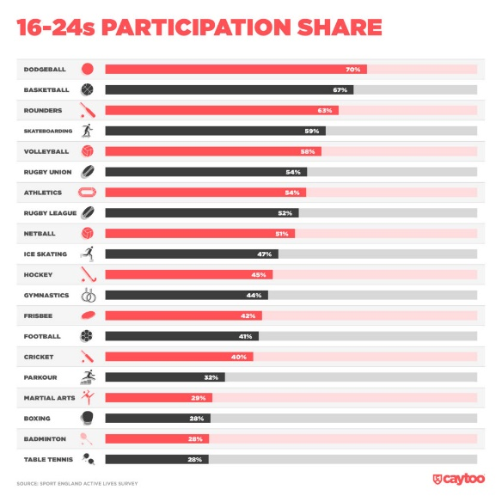

**Target Market**

* Who are you trying to target and why?

**Market Size and Structure**

* Niche or Mass markets

**Trends**

* Current trends (Ethical, environmental, social, technological)

**Competition**

* Who are your rivals?

**SWOT Analysis / PESTLE Analysis**

* Must have both

**Product Life Cycle**

* What stage is your product / service at – explain why?

**Justification**

* From looking at your research both primary and secondary justify why there should be a campaign for this product / service

**Reliability and Validity of Information researched**

* What is your sampling method for your primary research (Survey / Questionnaire)
* List your websites for your secondary research
* Make a statement that the research you carried out is from valid, reliable etc. sources / websites

**Section 2**

**Marketing Mix / Extended 7Ps**

* Must have all 7 – have sub headings for each

1. Product – what is the product, packaging
2. Price – what strategy will be used?
3. Promotion – how will the product be communicated?
4. Place – how will it be sold – e.g. online, shop
5. People – will employees have to be retrained – consider customer service
6. Physical environment – shop designs/ shop layout / décor have to be changed?
7. Processes – consider the making of the product, any technological changes?

**Marketing message**

* What is the key message, what are you trying to convey to the audience?

**Selection of Media**

* What methods of media will you use and why?

**Campaign Budget**

* Budget will be £?? – how will you spend this? Itemise each cost and make sure it adds up to the budget cost provided

**Timescale**

* Use your Gantt chart – also state in a sentence how long it will take for the campaign to start and finish